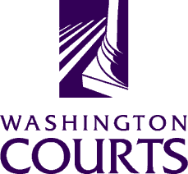 | Superior Court Judges’ Association Equality and Fairness Committee  Date and Time: Wednesday, August 15, 2018 @ 12:05 p.m. – 1:00 p.m.  Meeting Via Teleconference  Number: 1-877-820-7831 PW: 358515#
AGENDA
- Chair Report – Judge Helen Whitener
- Feedback on SCJA E&F mission

- Sub-Committee Updates
- Legislative (Judge Lucas)
- Media & Outreach (Judge Shea-Brown)
- Website posting process – See attached protocol
- Education (Judge Phelps)
- SCJA Spring Conference – Implicit Bias/ Mindfulness Training

- Color of Justice Programs
- Approval of sites – Yakima (November 2) & Thurston (October 16)

- Next Meeting – Wednesday, September 19 @ 12:05pm – 1:00pm

Committee material archiving – Please see link to OneDrive containing SCJA E&F current and archived materials: https://1drv.ms/f/s!AsngiM81_PG_f-sk-2-rjDvBSt8
Persons with a disability, who require accommodation, should notify Cynthia Delostrinos at 360-705-5327 or Cynthia.Delostrinos@courts.wa.gov to request or discuss accommodations. While notice 5 days prior to the event is preferred, every effort will be made to provide accommodations, when requested.

