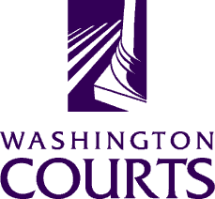 | Superior Court Judges’ Association Equality and Fairness Committee  Date and Time: Monday, September 19, 2016 @ 12:05 p.m.  Teleconference Call Number: 1-877-820-7831  Pin Code: 358515#
AGENDA
- Call to Order |  | Judge Eric Lucas
- Chair Reports |  | Judge Eric Lucas & Judge Helen Whitener
- Sub-Committee Reports  - Education  - Media/ Outreach  - Legislation/ Rules |  | Sub-Committee Chairs
- Joint Commissions Education Committee |  | Judge Andrea Darvas / Cynthia Delostrinos
- 2017 SCJA Spring Conference – RFP |  | Discussion / All
Persons with a disability, who require accommodation, should notify Cynthia Delostrinos at 360-705-5327 or Cynthia.Delostrinos@courts.wa.gov to request or discuss accommodations. While notice 5 days prior to the event is preferred, every effort will be made to provide accommodations, when requested.

